Qualitative Analysis Result

FGD Report

EXPLORING PARTICIPATORY SELF-HELP INTERVENTIONS FOR ELIMINATION OF OPEN DEFECATION IN RURAL AND URBAN COMMUNITIES OF NORTHERN NIGERIA.

This thematic analysis comprised of focus group discussion from six northern states: Borno, Gombe, Jigawa, Kano, Niger and Plateau state. Some of the common codes generated from this interview were represented in the word cloud in figure 1. From the word cloud chart, the most common codes lack of toilets facilities, open defecation, government provision, diseases, law, public health, sensitization, water, outside, faeces etc.

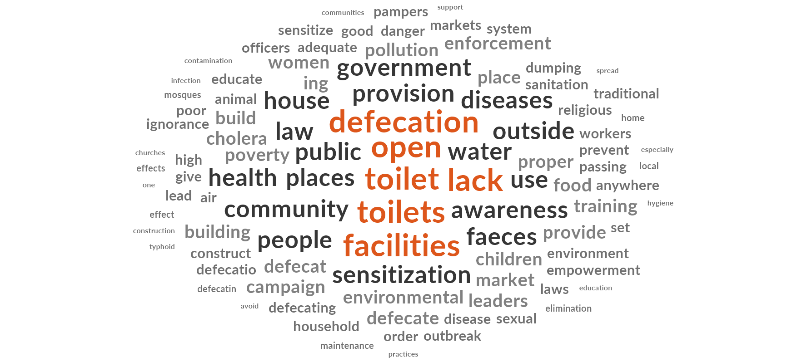

Project maps were included to gives a hierarchical model of how the themes on self-help interventions for elimination of open defecation were derived from bottom to top.

Question 1: What do you understand as open defecation

Theme 1: Defecating and disposing pampers in the public places

The majority of the participants defined open defecation as defecating in the public places and the indiscriminate disposal of sanitary pad and baby pampers. The public places include the street, market, bush or anywhere outside the home, a participant in Kano explained open defecation as throwing or disposing of pampers in places other than toilets

“Doing outside places set as toilets, Doing or passing faeces outside, doing outside toilet, Passing faeces in places other than toilets” (All 6 states).

|  |  |  |
| --- | --- | --- |
| Question 1 | Location | Respondents |
| Theme1. Defecating and disposing pampers in the public places | All 6 states | 16 |
| Defecating in the open where flies can perch | Borno | 1 |
| Defecating in the public | All 6states | 14 |
| Throwing children pampers with faeces | Kano | 1 |

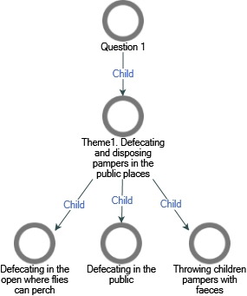

Figure 1. Project map on themes of the first research question

Question 2: What do you think is responsible for open defecation in your community? (Probe for lack of sanitary facilities, cultural or religious practices etc

Theme 1: Lack of sanitary facilities

The majority of the participants mentioned the lack of toilet facilities in many locations as the cause of open defecation. The lack of toilets was caused by environmental topography and lack of indoor toilet system. Environmental topography was mentioned by some of the participants in Borno and Plateau States.

“The nature of the soil that cannot support, rocky terrain are so difficult for the construction of toilet to a high depth” (Borno State).

“Environmental set up, especially hilly environment” (Plateau State).

Theme 2: Governmental Involvement

Some of the participants mentioned the laxity of the government in combating the surge of open defecation, such as poor government policies against the act, implementation and adherence to the policies as the causes of open defecation. Government should enforce strict law against open defecation, institute laws that will punish the offenders, some areas do not have local government area council funding.

“Lack of Local Government/Councillor funds to implement project” (Kano State).

“Poor implementation of government policies” (Niger State).

Theme 3: Poor socio-economic status and cultural practices

Poor socio-economic status such as poverty, overcrowding, poor hygiene, cultural practices were identified as some of the causes of open defecation. Some participants mentioned some cultural and behavioural practices such as taboos, does not like houses with in-built toilets, habits, negligence of parents and poor knowledge. Poor knowledge includes lack of awareness to the hazards of open defecation and the use of feaces as fertilizers. While, other participants mentioned population increase and overcrowding as the main causes of open defecation

“Lack of income, norms and culture, building toilet is unhygienic, toilet inadequacy” (Niger state)

“They see defecating in the house as a dirty thing. Misunderstanding it for fertilizer especially in villages” (Jigawa state).

|  |  |  |
| --- | --- | --- |
| Question 2 | Location | Respondents |
| Theme1. Lack of sanitary facilities | Borno, Gombe and Plateau | 4 |
| Environmental topography | Borno and Plateau states | 3 |
| Lack of toilet facilities | Gombe | 1 |
| Theme2. Governmental Involvement | Borno, Gombe, Kano, Niger and Plateau | 12 |
| Adhering to Government policies | Borno, Gombe, Kano, Jigawa, Niger and Plateau | 7 |
| Enforcing community law against open defecation | Borno, Niger and Plateau | 4 |
| Punishing defaulters | Borno | 1 |
| Indiscriminate refuse disposal | Borno | 1 |
| Lack of local government and council fund | Kano, Gombe and Plateau | 4 |
| Lawlessness and lack of law enforcement | Gombe and Plateau | 2 |
| Theme3. Poor socio-economic status and cultural practices | Borno, Gombe, Kano, Jigawa, plateau and Niger | 8 |
| cultural and behavioural practices | Borno, Gombe, Kano, Jigawa, plateau and Niger | 10 |
| Cultural practices | Niger | 1 |
| Does not like houses with in built toilets | Borno and Niger | 3 |
| Habits | Jigawa | 2 |
| Negligence of parents | Gombe, jigawa and Kano | 3 |
| Poor Knowledge | Gombe, Kano, Jigawa, plateau and Niger | 1 |
| Lack of awareness to the hazards of open defecation | Gombe, Kano, Jigawa, plateau and Niger | 6 |
| To prevent infection | Plateau | 1 |
| Use as Fertilizers | Jigawa | 1 |
| Population increase | Borno, Gombe, Kano and Niger | 4 |

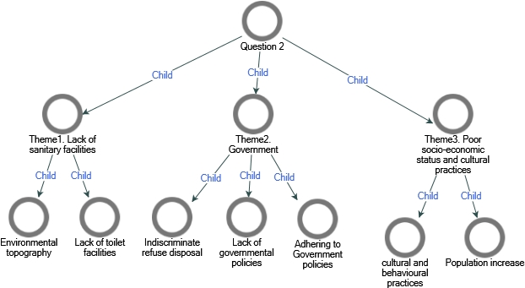

Question 3: What do you think are the health effects of open defecation (Probe for effect on children, women, and entire community?

Theme 1: Female Sexual harassment

Many of the respondents in Gombe, Niger and Plateau mention the hazard of open defecation as some form of sexual harassment such as rape, violation of the dignity of women and social stigma. Some respondents in Plateau mentioned the abduction of children as the hazards of open defecation

“Sexual assault, Social stigma. Dignity of women violated and social assault” (Gombe state).

“Sexual harassment and rape” (Niger state).

“Raping, kidnapping, and killing of women. Sexual abuse, rape” (Plateau state).

Theme 2: Environmental pollution and diseases outbreak

Respondents in Borno, Gombe, Kano, Niger and Plateau were able to identify some of the effects of open defecation. This includes all forms of environmental pollution, water pollution and disease outbreak such as cholera, typhoid etc.

“The ached faeces can go to water body and contaminate the water body Use salt and ash for disinfection” (Borno)

“Lots of effect of diseases transmission, flies’ infestations of food, cholera spread and outbreaks, typhoid/dysentery. Water pollution, environmental pollution, air pollution” (Gombe)

“Diseases, air pollution, qater pollution” (Kano state)

“Environmental pollution, cholera outbreak, children illnesses, nausea, outbreak of disease - cholera” (Niger state).

“Cholera, infection, dysentery. Air borne diseases, communicable diseases, worms and Typhoid fever. If there are spread /outbreak of diseases that lead to pandemic. Watery stooling and vomiting in children, dehydration. It brings about worm, skin rashes Infection” (Plateau state)

|  |  |  |
| --- | --- | --- |
| Question 3 | Location | Respondents |
| Theme1. Female Sexual harassment, Abduction and Kidnapping | Gombe, Niger and Plateau State | 7 |
| Abduction and kidnapping | Plateau | 1 |
| Socio stigma | Gombe | 1 |
| Theme2. Environmental pollution and diseases outbreak | Borno, Gombe, Kano, Jigawa, plateau and Niger | 11 |
| Animal infestation with worms | Borno and Jigawa | 3 |
| Offensive odour | Plateau | 1 |
| Reduction in shelf life of human | Jigawa | 1 |
| Spreading of infection | Borno, Kano, Jigawa, plateau | 5 |

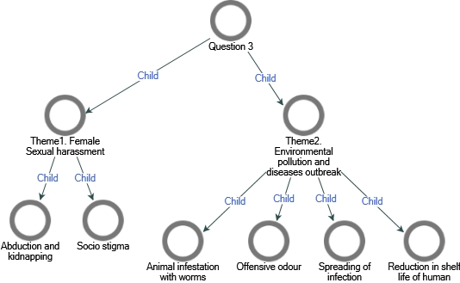

Question 4: What can every member of the community do to prevent open defecation?

Theme 1: Support Environmental health officers

The participants mentioned that the individuals can support the environmental health officers in various ways such as joining or volunteering to assist the officers, ensuring there are punishment meted out to individuals in the household who engage in open defecation

“Support to environment workers to do community activities” (Kano state).

“Each ward to get 15-17 people to be inspected open defecation to find out who are the ones practising open defecation” (Borno state)

Theme 2: Household regulation to prevent open defecation

Participants mentioned that sensitisation of the family by the head of the family, instilling discipline and punishment in the family for those who default are ways of preventing open defecation by an individual. This include disposal of all pampers properly, sensitization of family members and encouraging people to use alternative method of feaces disposal

“Sensitization of family members” (Niger state)

“Burn all pampers and pad to avoid filing the toilet.” (Borno state)

Theme 3: Individuals should build toilets in their homes

Some of the respondents in Borno, Gombe, Kano and Niger mentioned the need for individuals to build toilets in their homes

“Households should provide toilets. Toilet provision to be made compulsory” (Gombe state)

“Provision of toilets. 2. Provision of toilets in the houses to prevent children to go out.” (Kano state)

“Building toilet in the house to avoid open defecation. Provision of toilet facilities in the house e.g. 5 toilets for 15 people” (Niger state)

Theme 4: Sensitization and public health education

Some of the respondents mentioned that Individuals in the community can engage in sensitization about the effect of open defecation through health education of media e.g TV, education about open defecation. Some participants mentioned the abolition of Al majiris

“Jingles on elimination of open defecation. 5. Media outreach on elimination of open defecation.” (Gombe state)

“Health education program in Lapai TV to explain effect of open defecation.” (Niger state).

|  |  |  |
| --- | --- | --- |
| Question 4 | Location | Respondents |
| Theme1. Support Environmental health officers | Borno, Niger, Kano | 3 |
| get 15-17 people to be inspecting open defecation | Borno | 2 |
| Punishment meted on defaulting family members | Niger | 2 |
| Support environment workers | Kano | 1 |
| Theme2. Household regulation to prevent open defecation | Borno, Niger, Plateau | 4 |
| Dispose of all pampers properly | Borno | 1 |
| Sensitization of family members | Niger | 1 |
| Encouraging people to use alternative method of faeces disposal | Plateau | 1 |
| Theme3. Individuals should build toilets in their homes | Borno, Gombe, Kano and Niger | 5 |
| Provision of toilets | Gombe | 1 |
| Theme4. Sensitization and public health education | Gombe, Kano, Jigawa, plateau and Niger | 8 |
| Abolition of Al majiricin | Kano | 1 |
| Education about open defecation | Gombe | 1 |
| Health education of media e.g TV | Gombe and Niger | 2 |

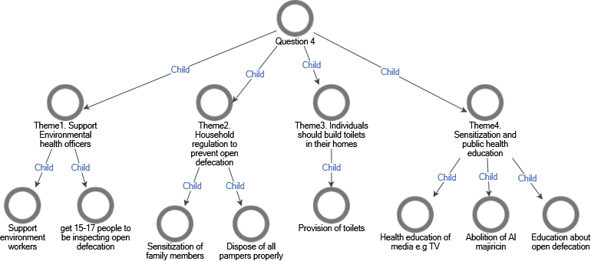

Question 5: What can individual organization do to prevention open defecation?

Theme 1: Government and community effort to eliminate open defecation

The respondents mentioned ways in which the community and government can work together in community participation which include maintaining the provided facilities, securing their environments, government to increase the number of health workers and avoiding corrupt practices.

“Health Education on personal hygiene” (Borno state)

“Expulsion or banishment of residents that refuse to abide by the law. Government and community to do their part of eliminating open defecation. Avoiding corruption by the supervisors. Follow up by the communities. Monitoring and follow ups” (Gombe State)

“Increase number of sanitary officers or workers in mosques 2. More environmental workers to be employed.” (Kano state)

“Market place to put gate and fencing to avoid intruders. Expulsion or banishment of residents that refuse to abide by the law. Community vigilante” (Niger State)

Theme 2: Health talk on open defecation

The participants mentioned that health awareness and sensitisation by the community, religious bodies, union, youth and government on the negative impact of open defecation as part of what an individual organization can do to prevent open defecation. In addition, public health organisation should observe and mark the world environmental day with adequate publicity.

“Rallies, participation in World Environment Day.” (Gombe state)

“Sensitization by Unions to explain the effects of open defecation. Use of religious and traditional leaders to restrict open defecation” (Jigawa State)

“Health talk/ sensitization on the aspect of open defecation. Sensitization. Sermons.” (Kano state)

“Environmental health officers to keep emphasizing. Talk show by youth organization. Sensitize congregation in Churches and Mosques.” (Niger state)

“The religious leaders’ should also build toilets in their churches and Mosques.” (Plateau state)

Theme 3: Maintenance of public facilities

The participants mentioned that there is a need to maintain the sanitary facilities that have been provided by the government as well as the supervision of the public toilet.

“Maintenance of public facilities to be hygienically fit for use.” (Gombe state)

“Supervision and Monitoring of public toilets in markets.” (Kano state)

Theme 4: Provision of mobile toilets

According to the participants, one of the things an individual organization can do is provide mobile toilets in some places such as markets, this increases the proximity and access to the toilet’s facility

“Provision of toilet / mobile toilets in public places” (Gombe state)

“Provide toilets at relevant locations at short distances.” (Kano state)

“Provision of toilet / mobile toilets in public places” (Niger state)

|  |  |  |
| --- | --- | --- |
| Question 5 | Location | Respondents |
| Theme1. Government and community effort to eliminate open defecation | Borno, Gombe, Kano and Niger | 1 |
| Avoiding corrupt practices among supervisors | Gombe | 1 |
| Expulsion of residents | Borno and Gombe | 2 |
| Follow up by the community | Gombe | 1 |
| Increase more environmental health workers | Kano | 1 |
| Security measure in the market such as gates | Niger | 3 |
| Theme2. Health talk on open defecation | Gombe, Jigawa, Kano, Niger and Plateau | 6 |
| Sensitization by religious bodies | Niger, plateau and Jigawa | 3 |
| Sensitization by unions | Jigawa | 1 |
| Sensitization by environmental health officers | Niger | 1 |
| Talk shows by youth | Niger | 1 |
| World environmental day | Gombe | 1 |
| Theme3. Maintenance of public facilities | Gombe and Kano | 3 |
| Supervision of public toilet | Kano | 1 |
| Theme4. Mobile toilets | Gombe, Kano and Niger | 2 |
| Proximity to toilet | Kano | 1 |

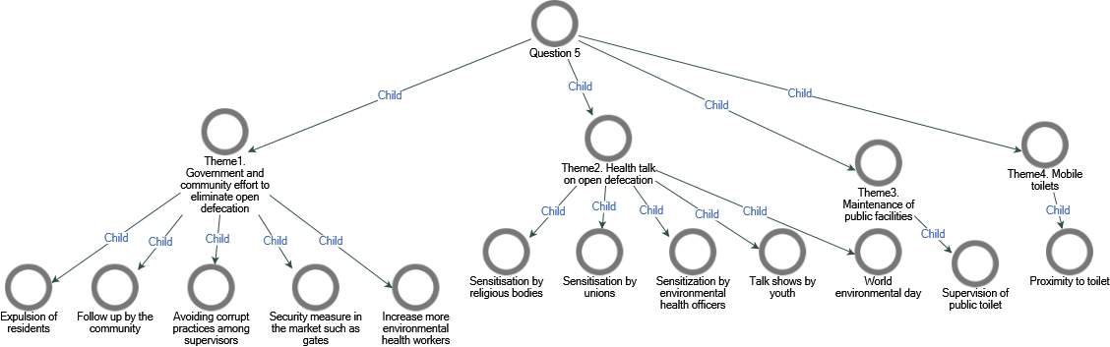

Question 6: What can the entire community do to prevent open defecation?

Theme 1: Community sanitation

As regards what the entire community can do to prevent open defecation, the participants mentioned that the community should embrace sanitation and hygienic practices such as organising a monthly sanitation day, abolition of indiscriminate dumping of refuse, proper waste management and provision of dumping sites etc.

“Community efforts to build toilet and hand over to LGA. Allowing environmental health officers to. Indiscriminate dumping sites attracts open defecation. Monthly sanitation last Saturday of the month. Proper waste disposal management system. Community stakeholders with resources to participate in the elimination” (Niger state).

“The community leaders can give a space where to dump the faeces and buried it” (Plateau state)

Theme 2: Religious body sensitisation

The participants mentioned that the religious leaders should use their influence to communicate the negative impact of open defecation to their members. They should also provide toilet facilities in their place of worship etc.

“Traditional leaders to plead with their people/subjects to effectively use their toilets.” (Gombe state)

“Awareness by religious and traditional leaders when facilities are provided” (Niger state)

|  |  |  |
| --- | --- | --- |
| Question 6 | Location | Respondents |
| Theme1. Community sanitation | Niger and Plateau | 6 |
| Abolition of indiscriminate dumping sites | Niger | 1 |
| Community effort at providing toilets | Niger | 1 |
| Participation in monthly sanitation | Niger | 1 |
| Proper waste management | Niger | 1 |
| Provision of dumping sites | Plateau | 1 |
| Theme2. Religious body sensitization | Gombe and Niger | 2 |
| Religious leaders should build toilet in places of worship | Niger | 2 |

